COAL – Lab 6 – Lab tasks

Task 1:
INCLUDE Irvine32.inc

.data
sum DWORD 0
count DWORD 0
prompt BYTE "Enter a number: ", 0
output BYTE "Total sum is: ", 0

.code
main PROC
mov ecx, 10

read_loop:
mov edx, OFFSET prompt
call WriteString
call ReadInt
cmp eax, 0
je done
add sum, eax
inc count
dec ecx
jnz read_loop

done:
mov edx, offset output
call writestring
mov eax, sum
call WriteDec
call Crlf
exit
main ENDP

END main

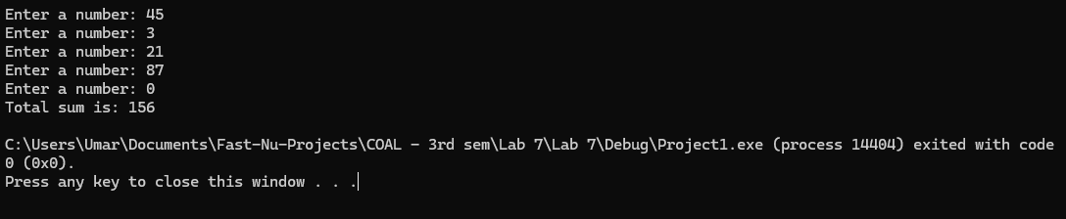

Task 1:
INCLUDE Irvine32.inc

.data
marks DWORD 0
grade BYTE ?
prompt BYTE "Enter marks: ", 0

.code
main PROC
mov edx, OFFSET prompt
call WriteString
call ReadInt
mov marks, eax

cmp eax, 90
jge gradeA
cmp eax, 70
jge gradeB
cmp eax, 60
jge gradeC
cmp eax, 50
jge gradeD
jmp gradeF

gradeA:
mov grade, 'A'
jmp done
gradeB:
mov grade, 'B'
jmp done
gradeC:
mov grade, 'C'
jmp done
gradeD:
mov grade, 'D'
jmp done
gradeF:
mov grade, 'F'

done:
mov al, grade
call WriteChar
call Crlf
exit
main ENDP

END main

